Assignment 4

1)Created 2 VMS, One is the master one and another is slave one.

Master node name= ansible-master

Slave node name = ansible-slave

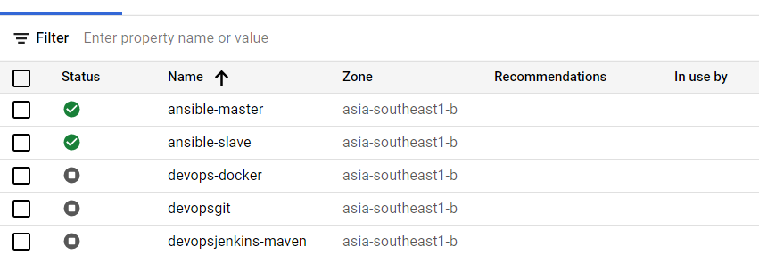

2)Configure the master node to enable password less authentication.

* In slave go to root and update sshd_config

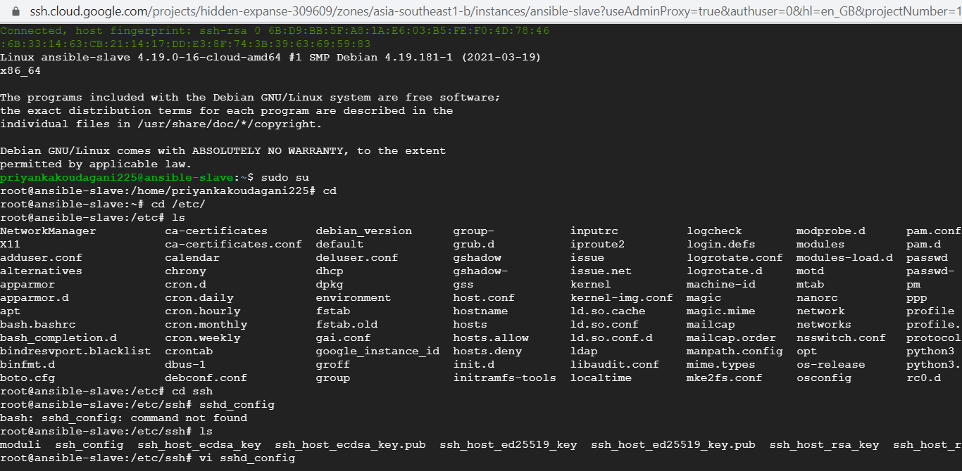

3)Change password authentication ad rootlogin to yes

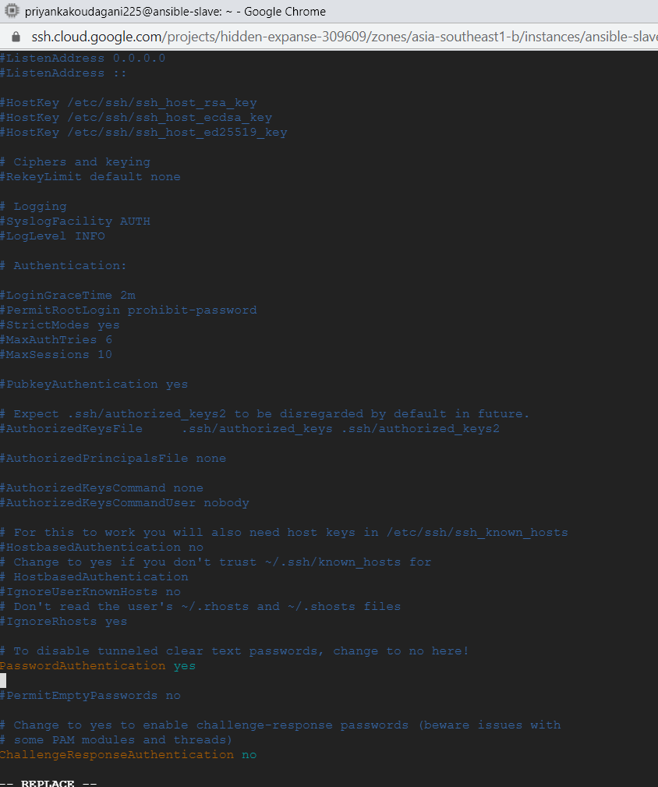

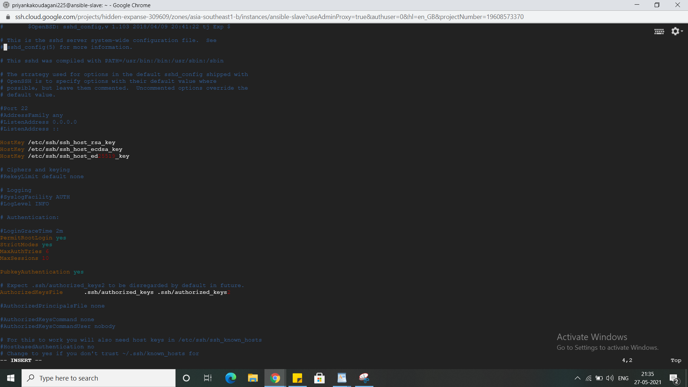

4)Restart sshd and set a password to be used from master to connect to slave

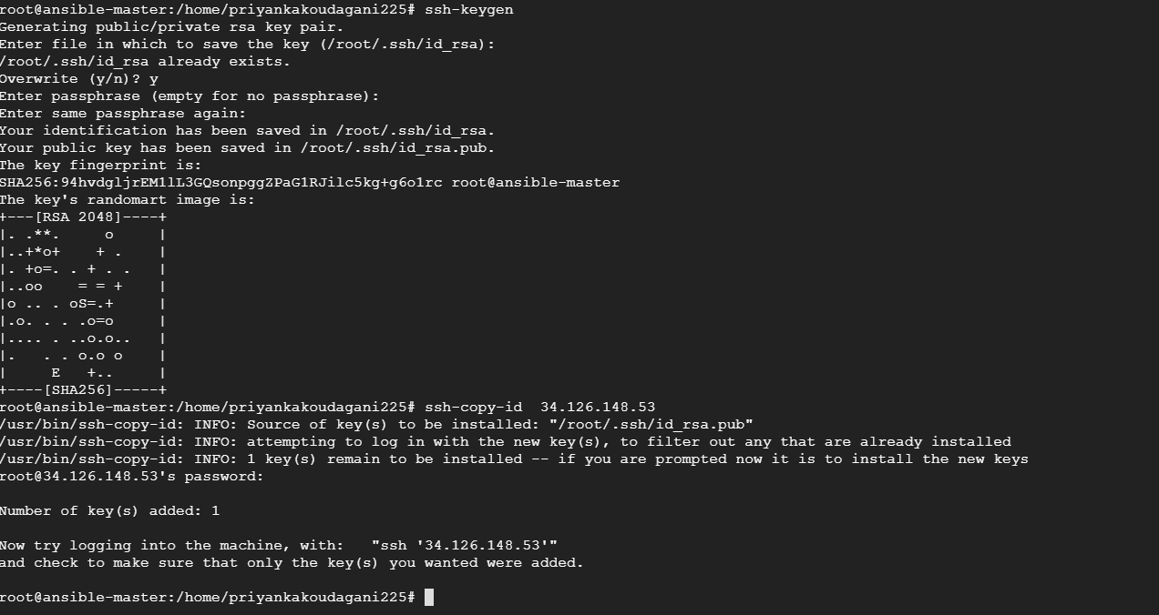

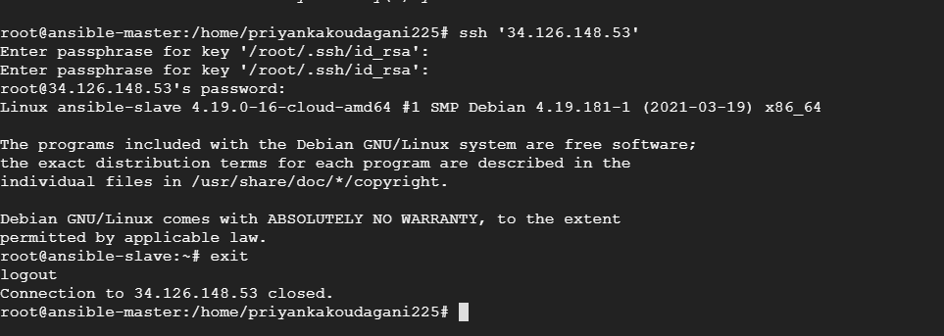5) installed asnible in master node and verifie ansible version

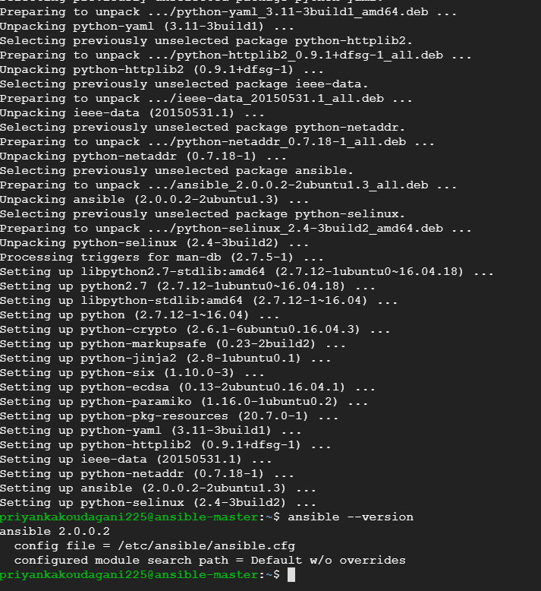

6)created entry in hosts file with slave-ansible host and ping is working fine as below

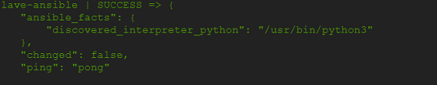

7)Write a playbook to install following software in the slave node

* Java
* Maven
* Nginx
* Docker

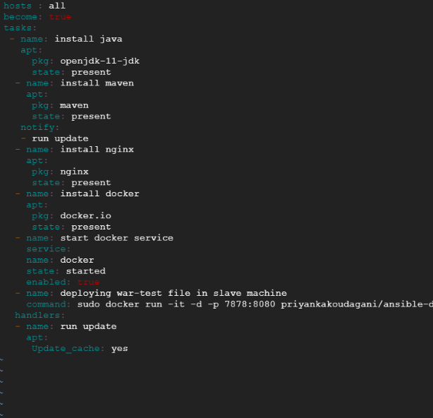

8)Run playbook and see if it is working

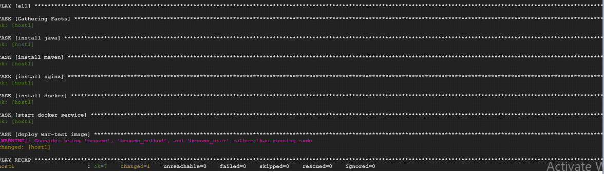

9) Created one tomcat image with war-test.war deployed and pushed it already to my dockerhub.

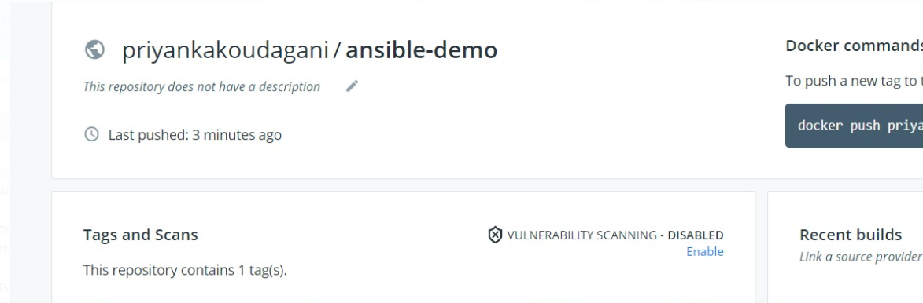

10)Please find below the version of installed packages (java, maven, nginx and docker) in slave node

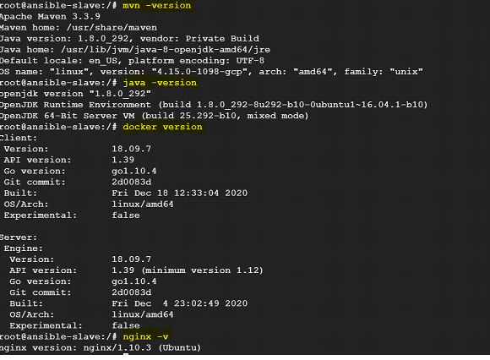

10)Application is accessible in slave node

